BBF PI & Coordinator Package:
Funding and Resources Gear

This package contains information regarding the Funding and Resources (FRG) intended for the in-country BBF Team (PI, Coordinator and Research and/or Administrative Assistant) and BBF Committee Members. It is organized into the following sections:

- General description of the Funding and Resources Gear
- Funding and Resources Gear Benchmarks and Examples - Table of all FRG Benchmarks, scoring information and examples
- Identification of Available Data- This template is to help the coordinator(s) in identifying the available data prior to the 1st Meeting. The BBF committee will use this form during that 1st Meeting to determine a) what remaining information is necessary and b) the actual benchmark scores. Provide as much detail as possible when completing this form to facilitate an efficient data gathering process.
- Data Gathering Action Plan- During the 1st Meeting, Gear Teams will set out their strategy to gather the remaining information required to score each benchmark to ensure efficient and comprehensive data collection. This plan should specify who is responsible, the likely data needed, the data collection strategy for each member, and the anticipated deadlines for collection.
- Data Organization and Benchmark Scoring Pathways- The purpose of the Data Organization templates are to help organize all the information collected for each benchmark and are intended to capture the multidimensional nature of each benchmark. The project coordinator ensures all data is available for the Gear Teams and they complete these forms. Teams will then use them in conjunction with the Scoring Pathways and corresponding tables to reach the benchmark score.

Scoring Pathways are designed to assist with the actual scoring - follow the arrows in order to score the benchmark. The corresponding tables are for documenting discussion, any changes to the scores, the scoring justification and final score. Gear Teams will summarize and present the results to the BBF committee during the 2nd and 3rd Meetings in order to facilitate consensus on benchmark scores.
- FRG1
- FRG2
- FRG3
- FRG4

- Recommended Actions - This table is for Gear Teams to outline/describe their proposed actions to address the gaps identified for the gear as a whole. These recommendations will form the basis of each Gear Team’s presentation during Meeting 4.

General description of the Funding and Resources Gear (FRG)

Key question: Is there adequate funding and other resources to scale up breastfeeding programs and interventions?

Background

Scaling-up breastfeeding programs requires adequate funding and other resources. The Breastfeeding Gear Model (BFGM) posits that, as breastfeeding legislation and policy is adopted, this should generate the allotment of adequate funding and resources to support implementation of those policies.⁶ Funding strategies that demonstrate country-level commitment to scaling up breastfeeding programs can include: specifying line-item funding for breastfeeding policies and programs in national budgets, ensuring funding is adequate for breastfeeding programs, and provide a formal mechanism to publicly fund maternity entitlements. Funding of human resources to support breastfeeding programs and initiatives is also a key step to ensuring breastfeeding legislation and policies are implemented at the national, subnational and local levels.

Benchmarks

The four benchmarks for the Funding and Resources Gear assess the availability and adequacy of country-level funding and other resources necessary to scale up national breastfeeding programs and initiatives. All benchmarks are referenced to “the past year” unless otherwise noted.

Domains

The benchmarks are designed to measure gear progress and they all have one or more Domain that assesses the different dimensions or elements within each benchmark:
Volume/Frequency: measures how much or how often
Quality: measures the quality of implementation
Effective (Operational): measures the adoption or level of incorporation
Existence: measure the actual presence of a program, legislation, policy, strategy, person, etc.
Coverage: measures the level of implementation (national, subnational, local)

Funding and Resources Gear (FRG) Benchmarks and examples

Benchmark | Benchmark Scoring |  |  |  | Examples
 | 0  Not done | 1  Minimal progress | 2  Partial progress | 3  Major progress
FRG1:  There is a national budget line(s) for breastfeeding protection, promotion and support activities. | There is no line in the national budget for breastfeeding protection, promotion and support activities. | There is a national budget line(s) for breastfeeding protection, promotion and support activities but it does not include more than two items in Annex 3. | There is a national budget line(s) for breastfeeding protection, promotion and support activities and it includes most line items in Annex 3. | There is a national budget line(s) for breastfeeding protection, promotion and support activities and it includes all line items in Annex 3. | In the US, the President's Budget for Fiscal Year 2017 includes funding of $8 million for the Centers for Disease Control (CDC) Baby-Friendly Hospitals/Breastfeeding programs.  Score: Minimal Progress  Existence: Yes  Quality: National budget line for breastfeeding protection, promotion and support activities does not include more than two items in Annex 3.
Annex 3: National Budget Line Items
- The National Breastfeeding Program
- The Baby Friendly Hospital Initiative/Ten Steps
- The International Code of Marketing of Breast Milk Substitutes monitoring and enforcement
- Maternity Protection
- Breastfeeding related Information, Education and Communication campaigns and materials
- Breastfeeding training and program delivery
FRG2:  The budget is adequate for breastfeeding protection, promotion and support activities. | There is no line in the national budget for breastfeeding protection, promotion and support activities. | There is a national budget line(s) for breastfeeding protection, promotion and support activities or there is not a specific budget line but funding is provided for breastfeeding resources and it is adequate to cover some but not the great majority of the activities in Annex 3 at the national level. | There is a national budget line(s) for breastfeeding protection, promotion and support activities or there is not a specific budget line but funding is provided for breastfeeding resources and it is adequate to cover all of the activities in Annex 3 at the national level. | There is a national budget line(s) for breastfeeding protection, promotion and support activities and it is adequate to cover all activities in Annex 3 at the national level. | In Brazil, a management report from Ministry of Health is published annually. In 2014, the National Budget Line for Child Health Care Policy described in the report included all the items listed in Annex 3. In addition, the report highlighted key actions accomplished in the year, challenges faced and a work plan for next year.  Score: Major Progress  Existence: Yes  Quality: There is a national budget line(s) for breastfeeding protection, promotion and support activities and it is adequate to cover all activities in Annex 3 at the national level.
FRG3:  There is at least one fully funded government position to primarily work on breastfeeding protection, promotion and support at the national level. | There is no government funded position to primarily work (i.e. 75% of time) on breastfeeding protection, promotion and support. | There is at least one government funded position to work on breastfeeding protection, promotion and support but it is not fully funded and the focus is not primarily breastfeeding. | There is at least one government funded position to work on breastfeeding protection, promotion and support and it is fully funded or the focus is primarily breastfeeding. | There is at least one government funded position to work on breastfeeding protection, promotion and support and it is fully funded and the focus is primarily breastfeeding. | In Brazil, the Coordinator of Breastfeeding and the Child Health Technical Office (within the Ministry of Health) is a completely government funded position. The primary focus of the position is to promote breastfeeding, complementary feeding, and health for children under 9 years old in the whole country, including States and municipalities.  Score: Major Progress  Existence: Yes  Quality: Government funded position is focused on breastfeeding protection, promotion and support and it is fully funded.
FRG4:  There is a formal mechanism through which maternity entitlements are funded using public sector funds. | There is no formal mechanism through which maternity entitlements are funded using public sector funds. | There is a formal mechanism through which maternity entitlements are funded using public sector funds but the national coverage is minimal (i.e. less than 50% coverage nationally). | There is a formal mechanism through which maternity entitlements are funded using public sector funds with partial (i.e. 50%) national coverage. | There is a formal mechanism through which maternity entitlements are funded using public sector funds with full national coverage. | The Special Supplemental Nutrition Program for Women, Infants, and Children (WIC) is a US based federally funded national program that provides assistance to nutritionally at-risk pregnant and breastfeeding women as well as children up to 5 years of age. Unlike entitlement funded programs, WIC relies on discretionary funds being appropriated annually by Congress. Thus each year, Congress decides whether it will fund WIC and if so, by how much.  In contrast, an entitlement program must be funded completely by public funds; thus it must fund as many individuals as meet the eligibility criteria. The number of individuals that are eligible for an entitlement program may fluctuate each year but under the legislation, the government is required to provide the funds needed for the program benefits. Since the WIC program is not an entitlement program, major progress hasn’t been made within the US regarding this benchmark.  Score: No Progress  Existence: Yes  Coverage: WIC is a program with national coverage but not an entitlement program. There is no formal mechanism in the US through which maternity entitlements are funded using public sector funds.  The Austrian maternity benefit system is funded at 70% from the Family Burdens Equalisation Fund (financed by contributions from employers- 4.5% of their salary bill and from general taxes) and 30% from public health insurance.  Score: Major Progress  Existence: Yes  Coverage: Maternity benefits are available nationally and through a formal, publicly funded mechanism.

Identification of Available Data
Funding and Resources Gear
This template is to help the coordinator in identifying the available data the national BBF committee will use to score the PG benchmarks. Provide as much detail as possible when completing this form to facilitate an efficient data gathering process.
Instructions: For each benchmark, the data required is described. Indicate in the Available Data column if that data is available: Yes (Y), No (N), Incomplete (I) or Don’t Know (DK).
Benchmark | Description of required data | Available Data  (Y/N/I/DK) | Reference/Data Sources  Describe where this data is located (e.g. website, report, person to interview, etc.)
FRG1: There is a national budget line(s) for breastfeeding protection, promotion and support activities. | Domain: Existence:  Where is the budget for breastfeeding activities? Is it national, state or departmental? Does it fall under multiple budgets?  Domain: Quality:  How do line items compare to Annex 3?
FRG2: The budget is adequate for breastfeeding protection, promotion and support activities. | Domain: Existence:  Is there a budget line for breastfeeding activities? What is the budget allocation for these?  Domain: Quality:  Is the amount sufficient to cover the activities in Annex 3?
FRG3: There is at least one fully funded government position to primarily work on breastfeeding protection, promotion and support at the national level. | Domain: Existence:  Who is the government funded breastfeeding person?  Domain: Quality:  Are they full or part-time? How much time does this person dedicate to BF? What is the grade of the position? I.e. supervisor. What entity/body funds this position and how much is covered by the government?
FRG4: There is a formal mechanism through which maternity entitlements are funded using public sector funds. | Domain: Existence:  What is the mechanism for earmarking funds for maternity entitlements? What entity or body is responsible? How is it funded?  Domain: Coverage:  How much of the population is covered and for how long?

Data Gathering Action Plan
Funding and Resources Gear (FRG)
This plan describes the strategy to gather information required to score each benchmark. The action plan must include a schedule of regular meetings or conference calls made in the intervening two months between Meeting 1 and Meeting 2. It is during this period that the Gear Teams must score their benchmarks.
Gear Team Members:
Benchmark | Assigned Team member(s) | Potential Data Sources | Data Collection Strategy
FRG1: There is a national budget line(s) for breastfeeding protection, promotion and support activities.
FRG2: The budget is adequate for breastfeeding protection, promotion and support activities.
FRG3: There is at least one fully funded government position to primarily work on breastfeeding protection, promotion and support at the national level.
FRG4: There is a formal mechanism through which maternity entitlements are funded using public sector funds.

Scheduled Meetings: Describe the dates/times, methods (i.e., skype, in person) and content of anticipated meetings.
Date | Time | Method  (skype, in person, etc.) | Meeting agenda items | Anticipated attendees

Annex 3: National Budget Line Items
- The National Breastfeeding Program
- The Baby Friendly Hospital Initiative/Ten Steps
- The International Code of Marketing of Breast Milk Substitutes monitoring and enforcement
- Maternity Protection
- Breastfeeding related Information, Education and Communication campaigns and materials
- Breastfeeding training and program delivery
Data Organization & Scoring Pathways
Funding and Resources Gear
Data Organization: Please provide as much detail as possible to facilitate accurate scoring of each benchmark and development of recommendations. The relevant Domains are in bold.
FRG1: There is a national budget line(s) for breastfeeding protection, promotion and support activities.
Existence:  Name of department(s)/state with budget line(s) | Quality:  List the items in Annex 3 (see below) covered by this budget line | References/ Data sources

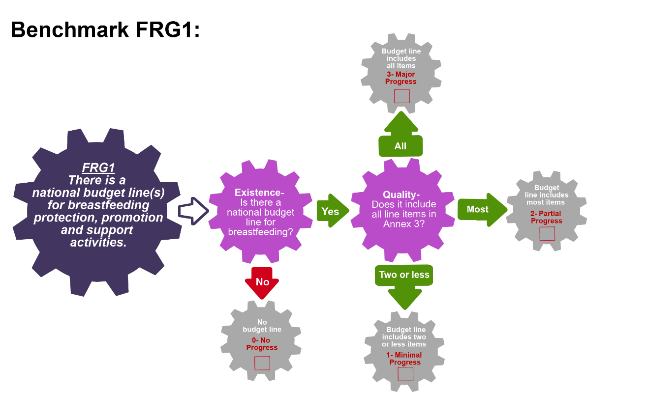
Scoring Pathway
☐
☐
☐
☐

**Insert the final score into the BBFI Calculator**
Instructions: Using the pathway, explain below the evolution of the final agreed score, i.e. rationale for any changes to the score, how the score was calculated (domains and criteria met), gaps identified and address any discrepancies of opinion within the Gear Team or Committee on the final score.
Date | Primary Score | Summary of Discussion | Scoring Justification | Final Score | Gaps identified
Between Meeting 1 and 2
Meeting 2
Meeting 3

Data Organization: Please provide as much detail as possible to facilitate accurate scoring of each benchmark and development of recommendations. The relevant Domains are in bold.
FRG2: The budget is adequate for breastfeeding protection, promotion and support activities.
Existence:  List the amount allocated in the budget(s) | Existence:  List the amount allocated to each line item from FRG1 | Quality:  Is this amount adequate to support the activities?  (Consider using past budget and activities to help answer this question for the current timeframe.) | References/ Data sources

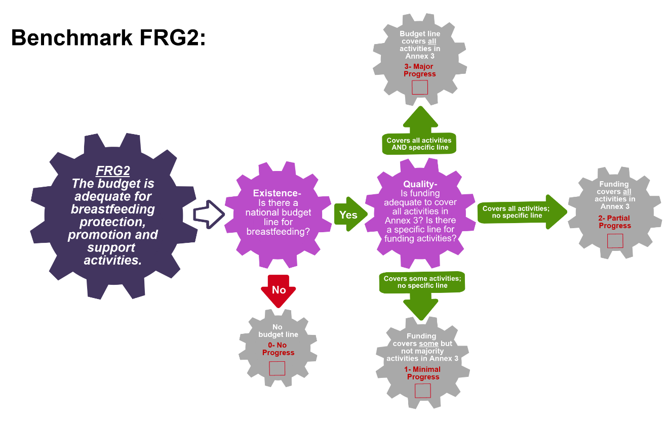
Scoring Pathway

☐

☐
☐
☐

**Insert the final score into the BBFI Calculator**
Instructions: Using the pathway, explain below the evolution of the final agreed score, i.e. rationale for any changes to the score, how the score was calculated (domains and criteria met), gaps identified and address any discrepancies of opinion within the Gear Team or Committee on the final score.
Date | Primary Score | Summary of Discussion | Scoring Justification | Final Score | Gaps identified
Between Meeting 1 and 2
Meeting 2
Meeting 3

Data Organization: Please provide as much detail as possible to facilitate accurate scoring of each benchmark and development of recommendations. The relevant Domains are in bold.
FRG3: There is at least one fully funded government position to primarily work on breastfeeding protection, promotion and support at the national level.
Existence:  Name the title of the position and grade | Quality:  Hours this person works per week and hours per week dedicated to BF | Quality:  Explain funding mechanism for this position, including source and percentage covered | References/ Data sources

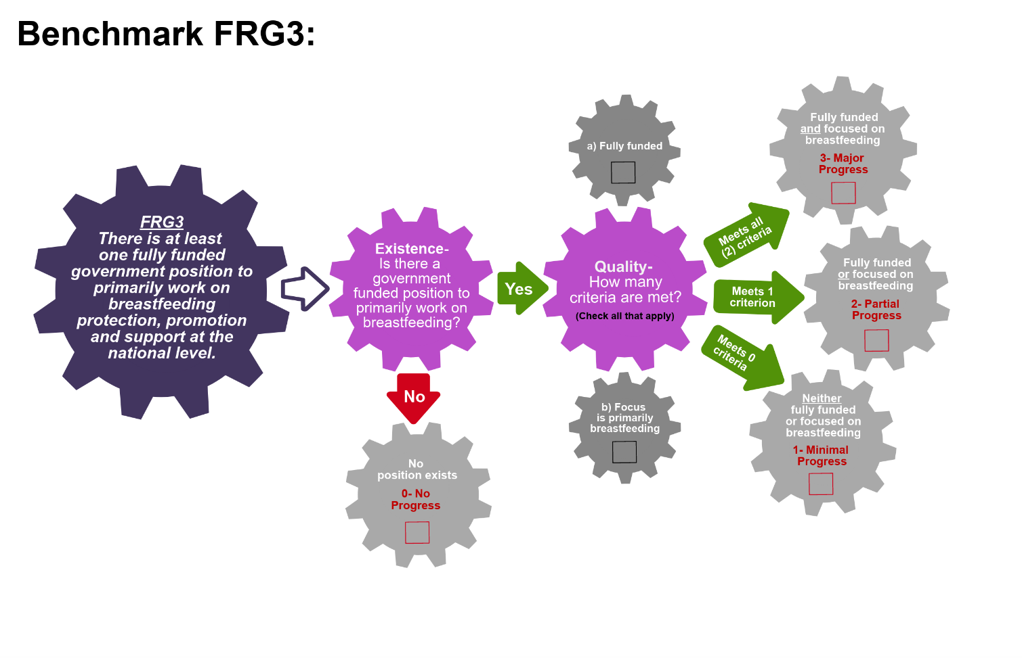
Scoring Pathway
☐
☐
☐

☐
☐
☐

**Insert the final score into the BBFI Calculator**
Instructions: Using the pathway, explain below the evolution of the final agreed score, i.e. rationale for any changes to the score, how the score was calculated (domains and criteria met), gaps identified and address any discrepancies of opinion within the Gear Team or Committee on the final score.
Date | Primary Score | Summary of Discussion | Scoring Justification | Final Score | Gaps identified
Between Meeting 1 and 2
Meeting 2
Meeting 3

Data Organization: Please provide as much detail as possible to facilitate accurate scoring of each benchmark and development of recommendations. The relevant Domains are in bold.
FRG4: There is a formal mechanism through which maternity entitlements are funded using public sector funds.
Existence:  Name the entity responsible for the maternity entitlement program | Existence:  Explain the mechanism through which they are funded | Coverage:  Provide numbers/percentage of the population covered by maternity entitlement program, include detail of any areas of the country/state where there is no coverage. | References/ Data sources

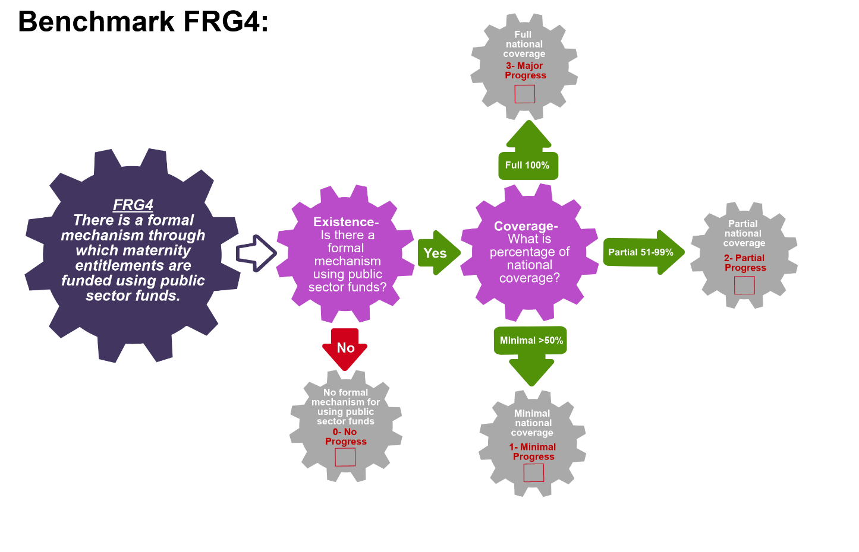
Scoring Pathway
☐

☐

☐
☐

**Insert the final score into the BBFI Calculator**
Instructions: Using the pathway, explain below the evolution of the final agreed score, i.e. rationale for any changes to the score, how the score was calculated (domains and criteria met), gaps identified and address any discrepancies of opinion within the Gear Team or Committee on the final score.
Date | Primary Score | Summary of Discussion | Scoring Justification | Final Score | Gaps identified
Between Meeting 1 and 2
Meeting 2
Meeting 3

Recommended Actions
Funding and Resources Gear (FRG)

This template can be used to summarize possible recommendations for improvement where benchmarks have scored No Progress (0), Minimal Progress (1) or Partial Progress (2). This summary will form the basis of each Gear Team’s presentation during Meeting 4. Guidance will be made available on developing recommendations and prioritizing them.
Gaps Identified | Recommended Actions

Adapted from Fox et al. (2015)

