BBF PI & Coordinator Package:
Promotion Gear

This package contains information regarding the Promotion Gear (PG) intended for the in-country BBF Team (PI, Coordinator and Research and/or Administrative Assistant) and BBF Committee Members. It is organized into the following sections:

- General description of the Promotion Gear
- Promotion Gear Benchmarks and Examples - Table of all PG Benchmarks, scoring information and examples
- Identification of Available Data- This template is to help the coordinator(s) in identifying the available data prior to the 1st Meeting. The BBF committee will use this form during that 1st Meeting to determine a) what remaining information is necessary and b) the actual benchmark scores. Provide as much detail as possible when completing this form to facilitate an efficient data gathering process.
- Data Gathering Action Plan- During the 1st Meeting, Gear Teams will set out their strategy to gather the remaining information required to score each benchmark to ensure efficient and comprehensive data collection. This plan should specify who is responsible, the likely data needed, the data collection strategy for each member, and the anticipated deadlines for collection.
- Data Organization and Benchmark Scoring Pathways- The purpose of the Data Organization templates are to help organize all the information collected for each benchmark and are intended to capture the multidimensional nature of each benchmark. The project coordinator ensures all data is available for the Gear Teams and they complete these forms. Teams will then use them in conjunction with the Scoring Pathways and corresponding tables to reach the benchmark score.

Scoring Pathways are designed to assist with the actual scoring - follow the arrows in order to score the benchmark. The corresponding tables are for documenting discussion, any changes to the scores, the scoring justification and final score. Gear Teams will summarize and present the results to the BBF committee during the 2nd and 3rd Meetings in order to facilitate consensus on benchmark scores.
- PG1
- PG2
- PG3

- Recommended Actions - This table is for Gear Teams to outline/describe their proposed actions to address the gaps identified for the gear as a whole. These recommendations will form the basis of each Gear Team’s presentation during Meeting 4.

General description of the Promotion Gear (PG)

Key questions: What promotional activities have occurred to support the scaling up of breastfeeding initiatives? What is the quality of those promotional activities?

Background

The BFGM posits that effective facility and community-based training as well as delivery of breastfeeding programs drives promotion efforts to communicate key breastfeeding messages and facilitate behavior change. Promotional strategies use a variety of methods (including social media, national and local events, campaigns, community activities, interpersonal skills) to convey breastfeeding messages to targeted audiences. Messages should be informative, culturally appropriate, motivational, accurate and concise so that they can be easily understood and readily accepted.

Benchmarks

The three benchmarks in this gear assess the existence and implementation of a National Breastfeeding Promotion Strategy and the level of awareness raised by government or civic societies about breastfeeding. All benchmarks reference “the past year” unless otherwise noted.

Domains

The benchmarks are designed to measure gear progress and they all have one or more Domain that assesses the different dimensions or elements within each benchmark:

Volume/Frequency: measures how much or how often
Quality: measures the quality of implementation
Effective (Operational): measures the adoption or level of incorporation
Existence: measure the actual presence of a program, legislation, policy, strategy, person, etc.
Coverage: measures the level of implementation (national, subnational, local)

Promotion Benchmarks and examples

Benchmark | Benchmark Scoring |  |  |  | Examples
 | 0  Not done | 1  Minimal progress | 2  Partial progress | 3  Major progress
PG1:  There is a national breastfeeding promotion strategy that is grounded in the country’s context | There is no national breastfeeding promotion strategy. | There is a national breastfeeding promotion strategy but it is not grounded in the country’s context nor is it time bound. | There is a national breastfeeding promotion strategy that is grounded in the country’s context but it is not time bound. | There is a national breastfeeding promotion strategy that is grounded in the country’s context and is time bound. | The Healthy Eating – Healthy Action (HEHA) strategic framework was launched in 2004 by the Ministry of Health in New Zealand as an obesity prevention strategy, which had highlighted breastfeeding as a key message. A multipronged approach was used to implement the HEHA from 2004-2010 and included a breastfeeding promotion campaign that targeted New Zealand women and their families, with specific focus on Māori and Pacific women with the goal of increasing breastfeeding support.  The strategy was fully grounded in the country’s context as it was developed based on the following:  - Review of policy development and existing services and programs in New Zealand and the international literature  - Epidemiological report and study looking at mortality as a result of poor nutrition  - Focus groups held around the country, which included Maori, Pacific peoples, researchers and academics, the public, primary and personal health providers, key interest groups, and food industry groups  - Consultation on draft strategy and publication of the analysis of this feedback  - International peer review of draft strategy  - Implementation plan set in place  Score: Major Progress  Existence: Yes  Quality (1): Strategy based on extensive research, pre-tested through focus groups and consultation to ensure the cultural, social, economic, and literacy appropriateness, therefore is considered grounded in the country’s context.  Quality (2): Strategy supported by the HEHA Implementation Plan for 2004 – 2010.
PG2: The national breastfeeding promotion strategy is implemented. | There is no national breastfeeding promotion strategy or, if there is, the national breastfeeding promotion strategy is not being implemented. | The national breastfeeding promotion strategy is being implemented but its effectiveness is unknown or has limited coverage (i.e. local coverage only). | The national breastfeeding promotion strategy is being implemented and it is effective but has partial coverage (i.e. subnational and local coverage only). | The national breastfeeding promotion strategy is being implemented, and it is effective and has high coverage (i.e. national, subnational, and local coverage). | In 2008, the New Zealand MOH received government funding to implement a national breastfeeding promotion campaign targeted to improve breastfeeding initiation and duration, especially among high risk groups, such as the Māori and Pacific mothers. This campaign was supported by the Healthy Eating-Healthy Action (HEHA) strategic framework and implementation plan, which had highlighted breastfeeding as a key message. The breastfeeding promotion social marketing campaign aimed to improve individual and environmental breastfeeding support among New Zealand women, especially among Māori and Pacific mothers. Since then, another breastfeeding social marketing campaign was launched in 2009 and then expanded to include other social platforms with the goal of increasing communication exchange about breastfeeding.  The Ministry of Health had commissioned an evaluation of the HEHA strategy and early findings showed that there was effective coverage for the targeted subpopulation and that they broadly supported the strategy. The strategy’s implementation was restricted in 2009 and then abandoned in 2011 due to a change in government.  Score: Minimal Progress  Existence: Yes  Effective: Due to the strategy not being fully implemented and the evaluations not completed, it is not possible to assess whether breastfeeding awareness and practices were increased as a result of the campaign.  Coverage: There is anecdotal evidence that the coverage of the target population was high but there was no formal evaluation done to support this.
PG3: Government or civic organizations have raised awareness about breastfeeding | Government or civic organizations actions have not raised awareness about breastfeeding | Government or civic organizations actions have raised minimal awareness about breastfeeding (i.e. reaching local level only). | Government or civic organizations actions have raised some awareness about breastfeeding (i.e. reaching local, subnational levels). | Government or civic organizations actions have raised strong awareness about breastfeeding (i.e. reaching local, subnational, and national levels). | In 2008, a regional government and a civic organization partnered to launch a breastfeeding promotion campaign targeted to young women, ages 16-25, in England. The Be a Star campaign highlighted local breastfeeding young mothers as “Stars” for breastfeeding. These mothers were featured in ad campaigns that transformed them to look like models, actresses, singers, etc. to emphasize that breastfeeding is glamorous. The goal of the campaign was to “support these women through the breastfeeding process, via peer support and improve understanding and acceptance of breastfeeding within the community”. Within the first few months of the campaign, breastfeeding initiation rates among the target group increased 11% in the region.  Score: Partial Progress  Coverage: Campaign was run at a regional level and breastfeeding awareness was raised.

Identification of Available Data
Promotion Gear (PG)
This template is to help the coordinator in identifying the available data the national BBF committee will use to score the PG benchmarks. Provide as much detail as possible when completing this form to facilitate an efficient data gathering process.

Instructions: For each benchmark, the data required is described. Indicate in the Available Data column if that data is available: Yes (Y), No (N), Incomplete (I) or Don’t Know (DK).
Benchmark | Description of required data | Available Data  (Y/N/I/DK) | Reference/Data Sources  Describe where this data is located (e.g. website, report, person to interview, etc.)
PG1: There is a national breastfeeding promotion strategy that is grounded in the country’s context | Domain: Existence:  This may include national, state or local promotion strategies that are specific to breastfeeding or reference breastfeeding promotion. Who is the governing body/organization(s)?  Domain: Quality (1):  How was the strategy developed? What formative research was undertaken to develop this strategy?  Domain: Quality (2):  What is the timeframe of the strategy? What are the implementation deadlines?  NOTE 1: A promotion strategy is a governmental or non-governmental document or initiative that aims to organize and/or systematize breastfeeding promotion efforts within the country/state. It can include formal campaign(s) (one or more) targeting specific or entire population and the relaying of messages through one/ multiple channels, i.e mass media campaigns, interpersonal communication, posters, educational materials, etc.
PG2: The national breastfeeding promotion strategy is implemented. | Domain: Existence:  What evidence of implementation is available?  Domain: Coverage:  Has the strategy been implemented nationally or at state or local level?  Domain: Effective:  What measures are in place to test the effectiveness of the strategy, i.e. raising awareness?
PG3: Government or civic organizations have raised awareness about breastfeeding | Domain: Coverage:  Who are the groups raising awareness? What type of activity do they undertake, i.e. social media campaigns? How is awareness-raising measured? How is promotional "reach" measured? Is the coverage local, regional or national?

Data Gathering Action Plan
Promotion Gear (PG)

This plan describes the strategy to gather information required to score each benchmark. The action plan must include a schedule of regular meetings or conference calls made in the intervening two months between Meeting 1 and Meeting 2. It is during this period that the Gear Teams must score their benchmarks.

Gear Team Members:

Benchmark | Assigned Team member(s) | Potential Data Sources | Data Collection Strategy
PG1:There is a national breastfeeding promotion strategy that is grounded in the country’s context
PG2: The national breastfeeding promotion strategy is implemented.
PG3: Government or civic organizations have raised awareness about breastfeeding

Scheduled Meetings: Describe the dates/times, methods (i.e., skype, in person) and content of anticipated meetings.
Date | Time | Method  (skype, in person, etc.) | Meeting agenda items | Anticipated attendees

Data Organization & Scoring Pathways
Promotion Gear (PG)
Data Organization: Please provide as much detail as possible to facilitate accurate scoring of each benchmark and development of recommendations. The relevant Domains are in bold.
PG1: There is a national breastfeeding promotion strategy that is grounded in the country’s context
Existence and Volume:  Describe the BF/IYCF committee and structure, including the frequency of meetings | Quality:  Name the members of the committee and their organizations, including those from civil organizations and/or sectors beyond health and nutrition | Quality:  Outline the objectives of the committee, including their time frames | References/ Data sources

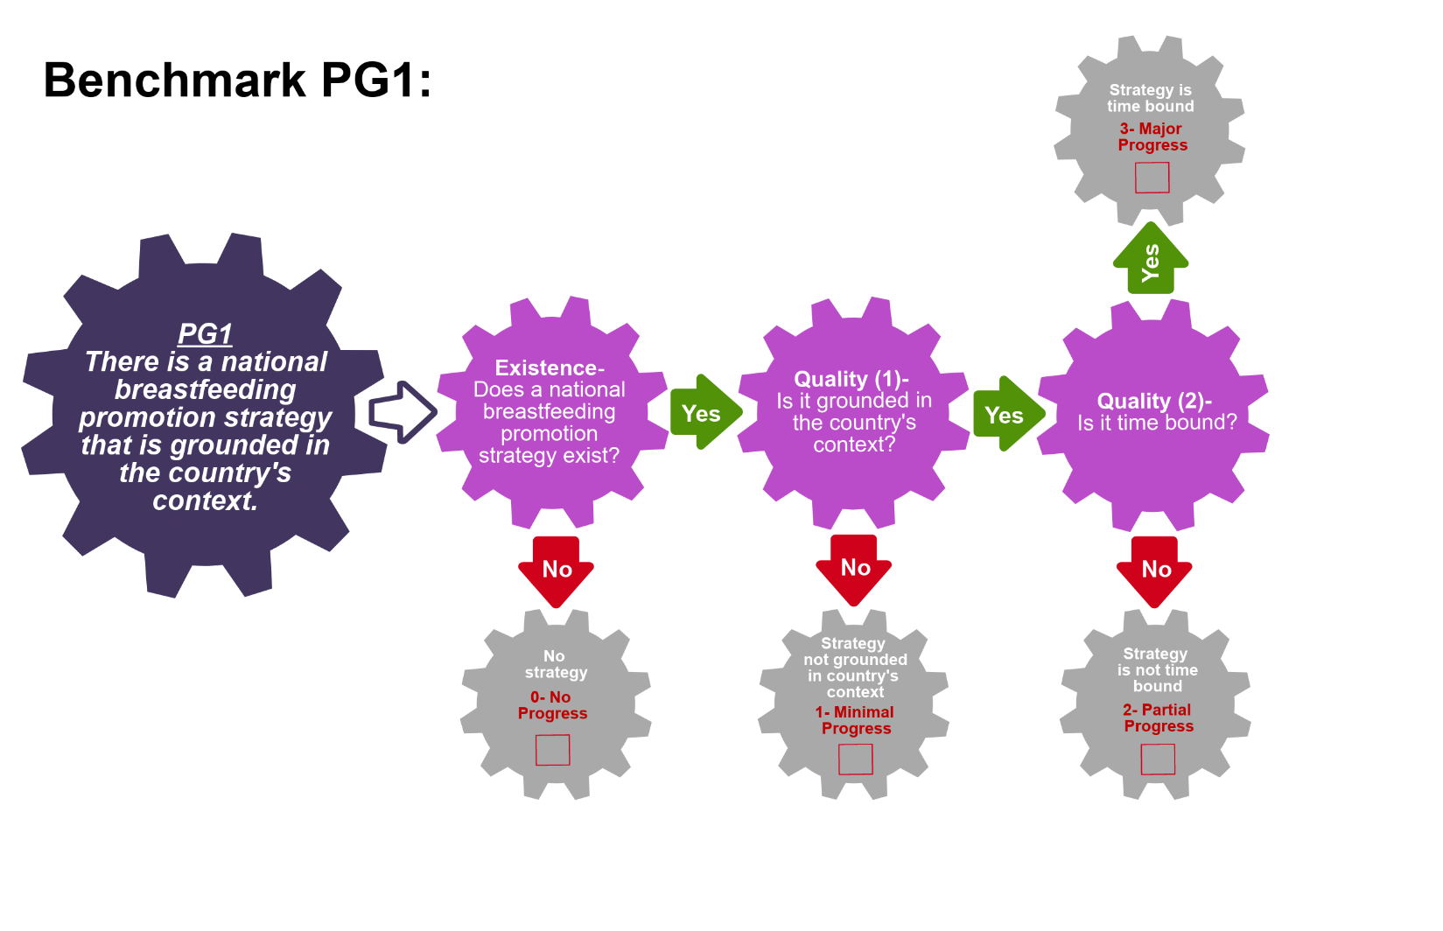
Scoring Pathway
☐

☐
☐

☐

**Insert the final score into the BBFI Calculator**
Instructions: Using the pathway, explain below the evolution of the final agreed score, i.e. rationale for any changes to the score, how the score was calculated (domains and criteria met), gaps identified and address any discrepancies of opinion within the Gear Team or Committee on the final score.
Date | Primary Score | Summary of Discussion | Scoring Justification | Final Score | Gaps identified
Between Meeting1 and 2

Date:
Meeting 2

Date:
Meeting 3

Date:

Data Organization: Please provide as much detail as possible to facilitate accurate scoring of each benchmark and development of recommendations. The relevant Domains are in bold.
PG2: The national breastfeeding promotion strategy is implemented.
NOTE: If the country/state does not have a National Breastfeeding Committee/IYCF Committee, this benchmark must be scored as no progress.
Existence:  Describe the status of the work plan, i.e. under development, in progress or under review | Effective:  Explain who is responsible for reviewing and monitoring the plan | Effective:  Explain the frequency of review & monitoring activities | References/ Data sources

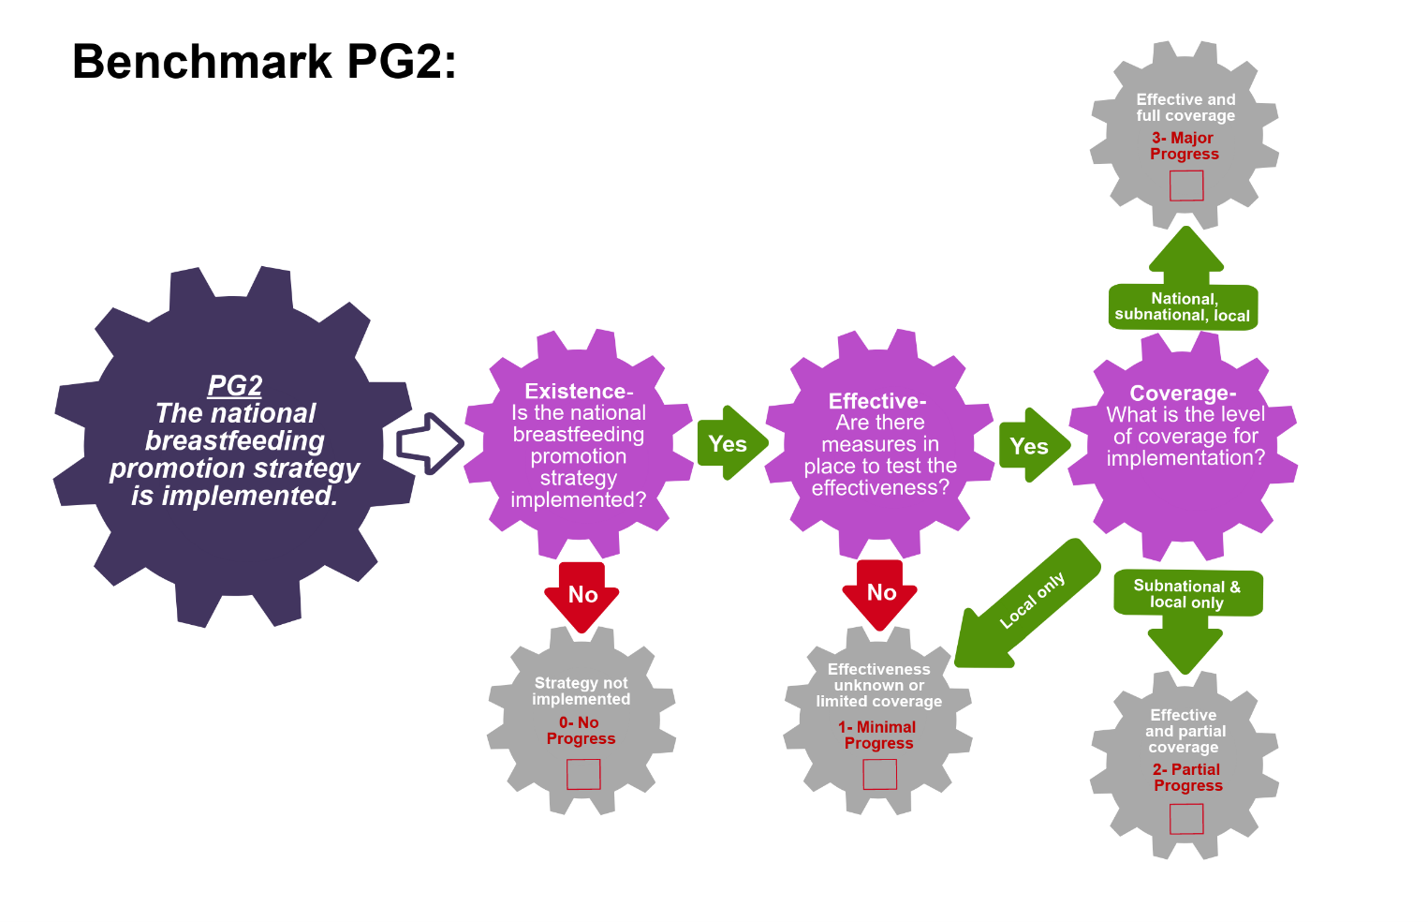
Scoring Pathway

☐
☐
☐
☐

**Insert the final score into the BBFI Calculator**
Instructions: Using the pathway, explain below the evolution of the final agreed score, i.e. rationale for any changes to the score, how the score was calculated (domains and criteria met), gaps identified and address any discrepancies of opinion within the Gear Team or Committee on the final score.
Date | Primary Score | Summary of Discussion | Scoring Justification | Final Score | Gaps identified
Between Meeting1 and 2

Date:
Meeting 2

Date:
Meeting 3

Date:
Data Organization: Please provide as much detail as possible to facilitate accurate scoring of each benchmark and development of recommendations. The relevant Domains are in bold.
PG3: Government or civic organizations have raised awareness about breastfeeding
Volume:  Describe available evidence of data-driven decision making and advocacy, including frequency of occurrence | Volume:  List the protocols reviewed | Volume:  Describe how data is used to provide feedback to policy makes | References/Data Sources

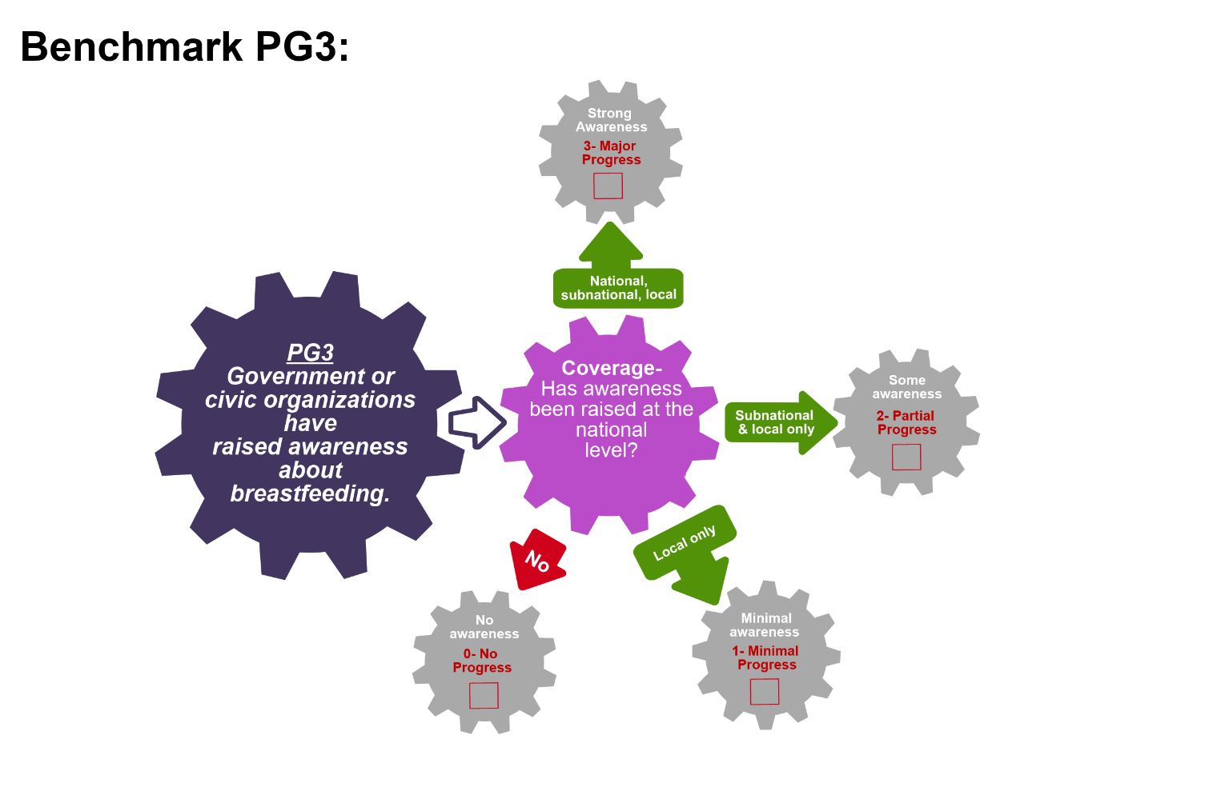
Scoring Pathway

☐
☐

☐
☐

**Insert the final score into the BBFI Calculator**
Instructions: Using the pathway, explain below the evolution of the final agreed score, i.e. rationale for any changes to the score, how the score was calculated (domains and criteria met), gaps identified and address any discrepancies of opinion within the Gear Team or Committee on the final score.
Date | Primary Score | Summary of Discussion | Scoring Justification | Final Score | Gaps identified
Between Meeting1 and 2

Date:
Meeting 2

Date:
Meeting 3

Date:

Recommended Actions
Promotion Gear (PG)

This template can be used to summarize possible recommendations for improvement where benchmarks have scored No Progress (0), Minimal Progress (1) or Partial Progress (2). This summary will form the basis of each Gear Team’s presentation during Meeting 4. Guidance will be made available on developing recommendations and prioritizing them.

Gaps Identified | Recommended Actions

